# The Pennsylvania State University

# IST 440W: Information Sciences and Technology Integration and Problem Solving

Section 001

20 February 2022

# Progress Report for Analysis Phase

# Chang Woo Shin – Participant

# Christopher Paez - Participant

# Israa Jeddeeni - Participant

# Tabitha Haripaul - Participant

# Mbinya Mutuku – Participant

***Table of Contents***

* **Summary Paragraph...................................................................** **3**
* **Task Completed.........................................................................** **4**
* **Task Completed.........................................................................** **5**
* **Task Started............................................................................... 5**
* **Task Started...............................................................................** **6**
* **Next Steps.................................................................................. 6**
* **Next Steps..................................................................................** **7**
* **Problems / Challenges...............................................................**  **7**
* **Work Breakdown Structure.......................................................** **8**
* **Work Breakdown Structure.......................................................** **9**
* **References..................................................................................** **10**

**Summary Paragraph:**

Throughout this document, our team Group 2 or MACIT, will discuss all updates, progress, setbacks, and upcoming goals. In the last progress report, MACIT reported the completion of the Group Contract and the Project Definition Report (PDR). Moving the project to the Analysis Phase, the group reviewed the company’s problems, goals, and mission to ensure that the Analysis Phase met the needs of the company. In this phase, the group engaged in extensive brainstorming and research to meet the requirements. From the requirements of the company, MACIT was able to offer alternatives to the solutions to the company in the Solutions Alternatives Document. In this document we listed recommended solutions in a ranking system listing and providing requirements (functional and non-functional), prices, advantages, and disadvantages. When conducting research for the selection of alternatives, the group ensured that the solutions presented were scalable, provided security, reviewed the total cost of ownership, provided rapid application development and was agile. MACIT also strived to supply Commercial Off-The-Shelf (COTS) and Non-Commercial Off-The-Shelf (NonCOTS) options for the company to select from.

Throughout the Analysis Phase, MACIT faced a few challenges. One of our group members took some medical leave. While this situation had the possibility to deter the progress of the group, the group members worked together to ensure the best product was provided to the client. In the coming weeks, the group will be moving into the Design Phase with the goal of delivering: Design Requirements Document (A draft and final submission.) Additionally, the group will strive to provide documents that are cohesive and provide a clear path to the outcome.

**Tasks Completed:**

* Completed a project breakdown structure (WBS) to clarify the areas of research
* Researched multiple Commercial Off The Shelf (COTS) packages that can be used as solutions toward problems
* Completed a project definition report to structure project outline
* Team created NonCOTS for some solutions
* Researched more Commercial Off The Shelf (COTS) packages to find better solutions
* Completed Stakeholders Analysis

The team has completed researching and comparing multiple Commercial Off The Shelf packages and Non- Commercial Off The Shelf for the problems and have decided solutions for the problems. For problem A, where the company needed to create a training method for employees and updating the new information security polices, the team has decided to utilize third party, COTS, training. ESET cybersecurity awareness training will be conducted to all the employees including the team leaders. With the training, all the employees will be educated on the importance of information security and what to expect when there are network security breaches. Also, with this training, the company will update and create new employee information security policies manuals. The manuals will be a guideline for all existing employees and training materials for new employees as well.

For problem B, employees monitoring program, the team has decided to use Teramind UAM which is COTS program. Compared with other COTS programs, Teramind UAM has the most features and fits the best for the solutions. Teramind UAM offers multiple features that can be used by leadership to monitor employees onsite and online. With this employee monitoring program, it will bring positive aspect to the workplace and increase work efficiency for all the employees.

The team has completed stakeholders’ analysis and summarized who are the most important influenced stakeholders for the project. The owner and board members are the most influenced stakeholders for the project, where they have all the decision making.

**Tasks Started:**

* Further research on NonCOTS solutions for problem C
* Started brainstorming for Design requirement document
* Started to create budget and timeline for the solutions

The team has started on coming up with NonCOTS solution for problem C. One of the NonCOTS solutions that team has come up with is creating recovery plan for all the data. Disaster recovery is an organization technique of recovering access and functionality to its IT infrastructure. With this plan, the team will be adapting to the disaster recovery plan and come up with solutions for problem C. The company can do a live demonstration of disaster recovery simulations and find out what can be improved for this recovery plan. There is some more work that has to be done to apply this recovery plan as a solution. The team have to do further research on the timeline of the recovery plan, what can happen when the server crashes, where the backup server will be located and other more research.

With all the solutions, the team has started to create a budget and timeline for all the solutions. Price can be the most critical part when it comes to projects, the budget has to meet the standard. Also, all the project solutions have to be done in the planned time, so that the company can finish the project and introduce the new outcome to customers. Listing all the costs and prices has been started by the team.

The team has started to brainstorm ideas for the design requirements document. This document will be the most important deliverable of the project, so the team has decided to start ahead. Each team member is brainstorming specific diagrams and charts to support solutions.

**Next Steps:**

* Work on completing the Rough Draft of Design Requirements
  + “Skeleton” descriptions of how each sub-problem is to be solve by final system solution
  + Complete description of COTS package proposed for track subproblem
  + Description of protocols, rules, etc.
  + A complete design description of the design for all training, advertising, websites, etc. Proposed as part of the marketing plan.
* Each member needs to complete a stakeholder analysis
* Once the Rough Draft of the Design Requirements is completed, then our team will work towards creating of Final Draft of the Design Requirements

MACIT is wrapping up the Analysis Phase of the project. The only parts left in the Analysis Phase are submitting this project report and Stakeholder Analysis by the end of the day.

The next step in the timeline is entering the Design Phase of the project. During this phase our team will work on describing how each sub problem will be solved by the COTs and NonCOTs packages we have chosen. Furthermore, MACIT will work on describing the protocols and rules that QuickBook employees will use. Additionally, the marketing plan will be explained further, so that the upper management of the QuickBooks company can start having an idea of what the marketing plan will be and prepare to enact it, in the next couple of months.

**Problems/ Challenges:**

* The team has encountered problems with research for Business problem C, the approach and materials to look for as IT cloud base or business customer advertisement based on marketing.
* The team is relatively new and has some fundamental issues when working together as a team on the overall overview of the project and how to focus on the entire system that can benefit the new company.
* The team needs to figure out how the COTS software will work best and be the most cost effective. Understanding the COTS overall process and estimating the cost and budget will enable the team to move in one direction.
* The team lacks cohesiveness in their deliverables due to schedule differences which include time differences. The team will work into looking and setting best time to work together through zoom meetings and other methods to resolve this issue.
* The team encountered problems with the research on design software on creating security policies on how to best train the company.

**Work Breakdown Structure:**

**Using Excel:**

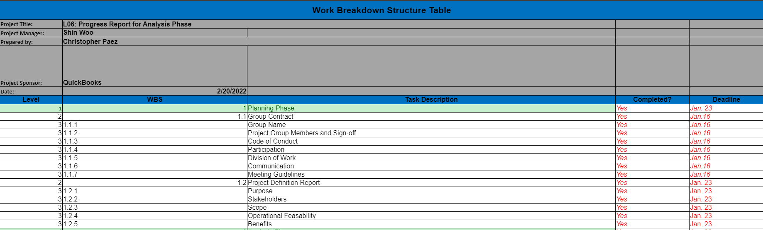

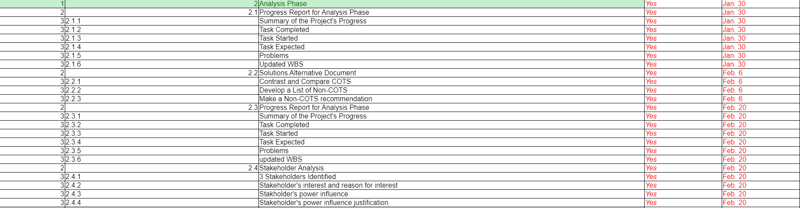

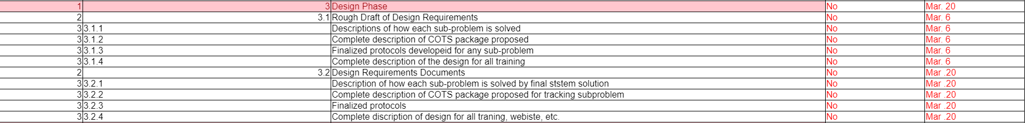

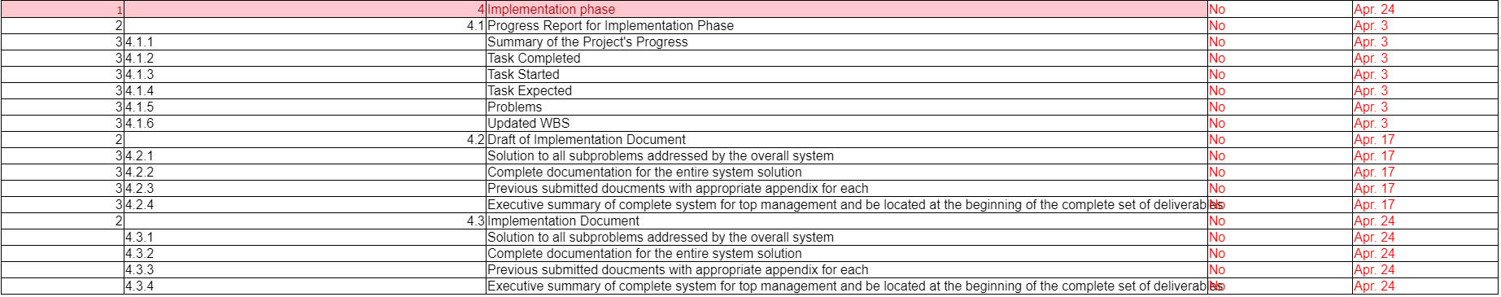

**References**

McAllister, N. (2022, January 20). *The Best Employee Monitoring Software for 2022*. PCMAG. Retrieved February 4, 2022, from <https://www.pcmag.com/picks/the-best-employee-monitoring-software>

SecurIT. (2021, August 13). *PCI, PII, phi: Putting a focus on security compliance + protection*. SecurIT. Retrieved February 4, 2022, from <https://www.securit.biz/en/blog/all-the-pxis-pci-pii-phi-putting-the-p-back-in-protection-of-the-enterprise>

Teramind . (2022, February). *Teramind UAM Price*. Teramind. Retrieved February 4, 2022, from <https://www.teramind.co/product/price>

Teramind. (2022, February). *Teramind Features*. Teramind. Retrieved February 4, 2022, from <https://www.teramind.co/features/ueba-user-and-entity-behavior-analytics>

Veriato. (2022, February). *Veriato Vision Price*. Veriato. Retrieved February 4, 2022, from <https://veriatocloud.com/cart/checkout/placeorder/653>

Veriato. (2017, March 17). *The disgruntled employee insider threat*. Veriato Blog - Employee Monioring & Insider Threat News 1. Retrieved February 4, 2022, from <https://blog.veriato.com/the-disgruntled-employee-insider-threat>

Work breakdown structure (WBS) | excel template free. (n.d.). Retrieved February 20, 2022, from <https://www.stakeholdermap.com/project-templates/WBS-excel-template.html>